BUSINESS, WEB AND SOCIAL MEDIA ANALYSIS
CRN - 48449
Group Assignment – Case study 1
NAME: ADITYA SHROFF
COLLEGE ID: 101539669
DATE: 05/03/25

CASE STUDY 1 – CHARLES BOOK CLUB

STEP 01 – EDA

- Generate summary of all the columns using info command
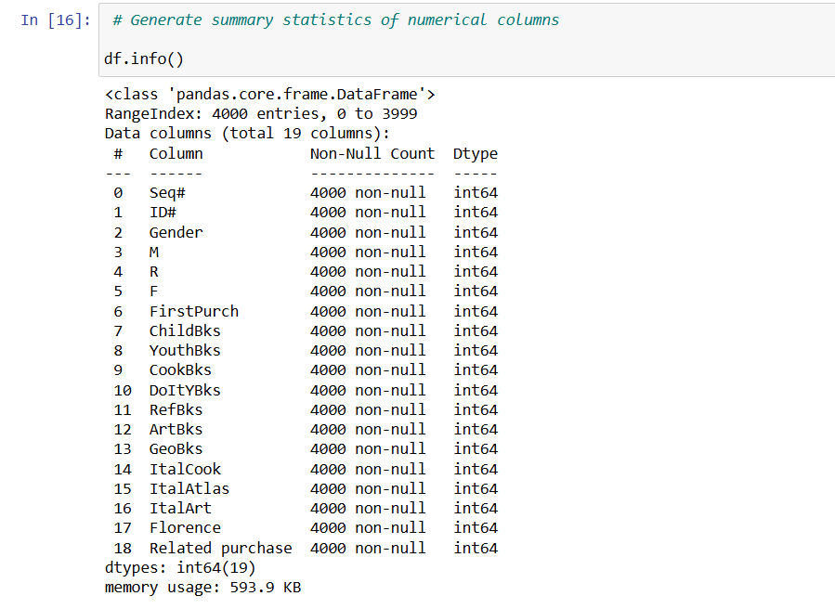

Handling inconsistent data types and removing outliers
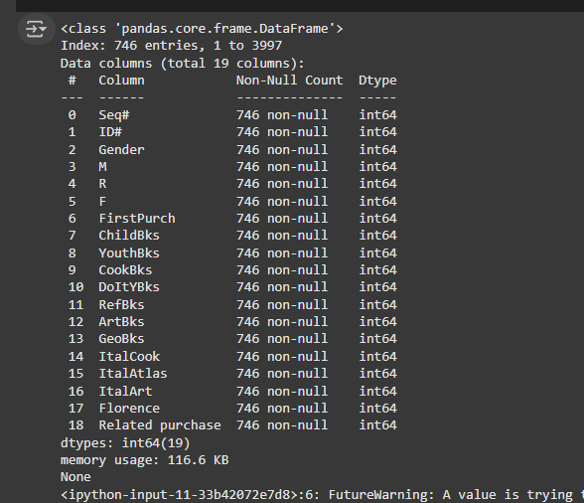

Histogram for total money spent on books
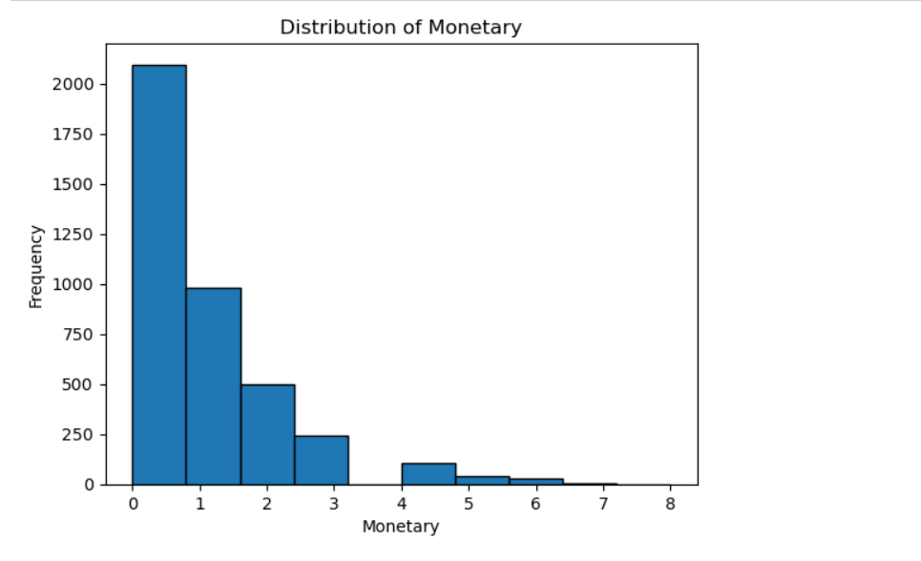

Heatmap representing co-relation between any possible 2 variables
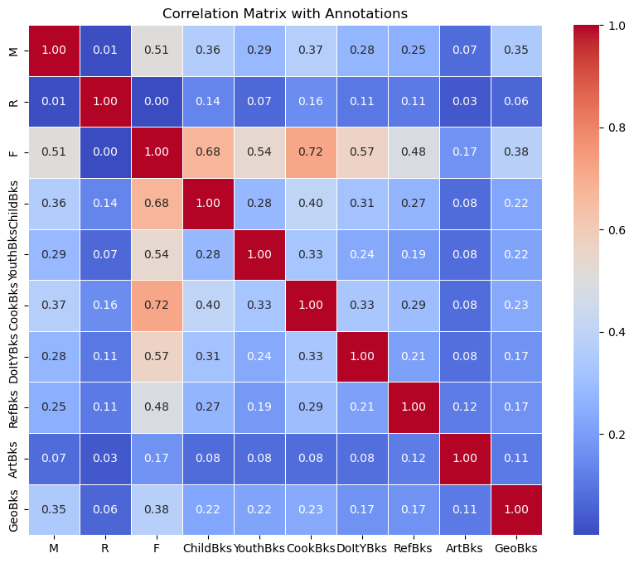

- Heatmap representing co-relation between all categories of books
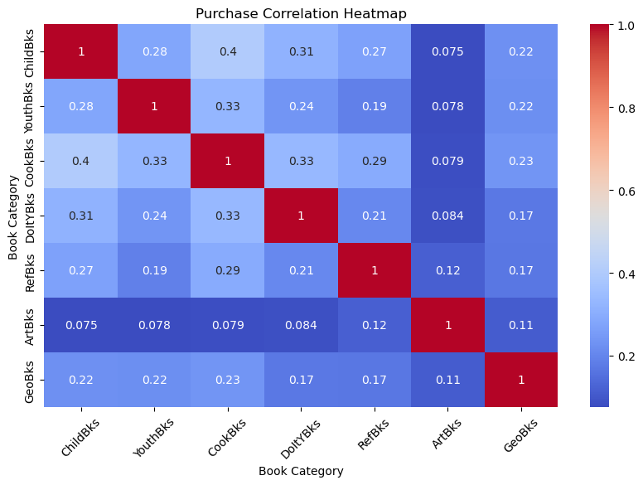

- A graph of the number of purchases made by gender.
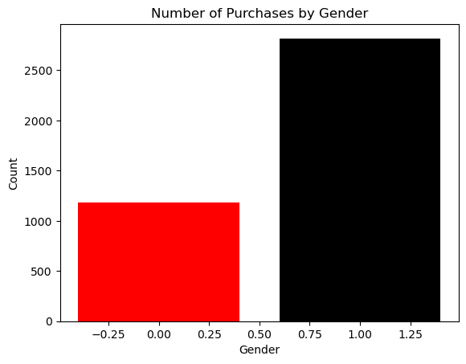
- A stacked graph showing the number of purchases by different categories, and segregating them by males and females 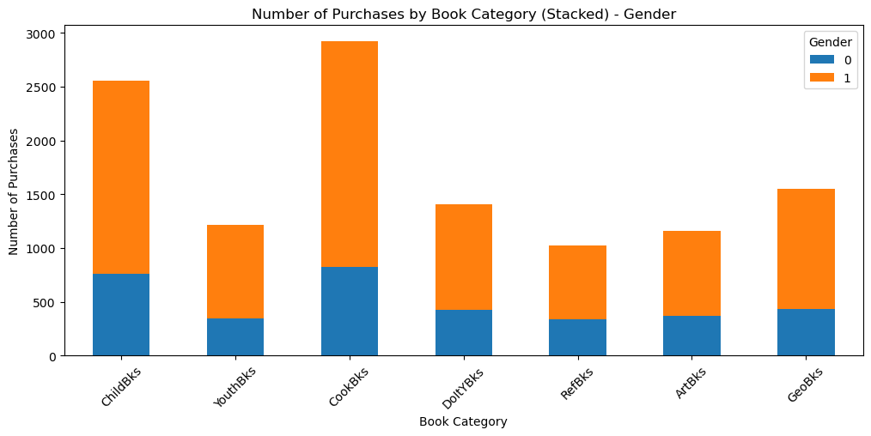

- Distribution of monetary value based upon the gender

CUSTOMER SEGMENTATION ACCORDING TO THEIR BUYING PATTERNS 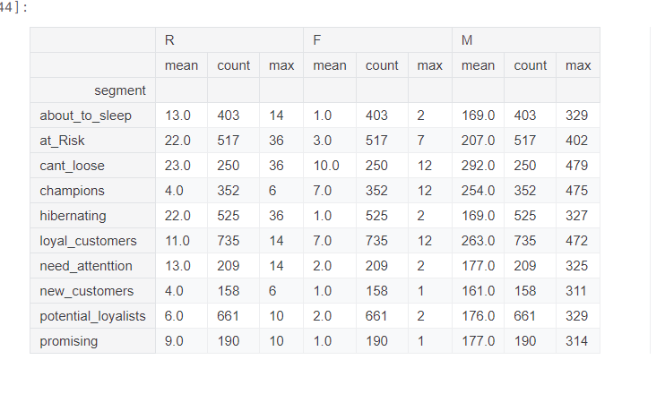

Linear Regression Model Using advertising spend and pricing as predictors.

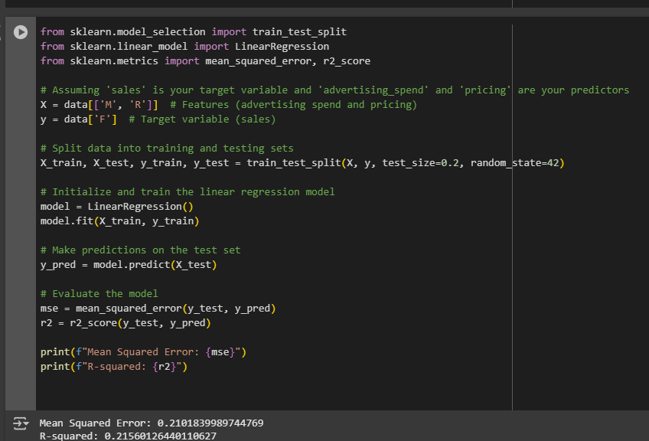

PRECISION, RECALL AND F1- SCORE

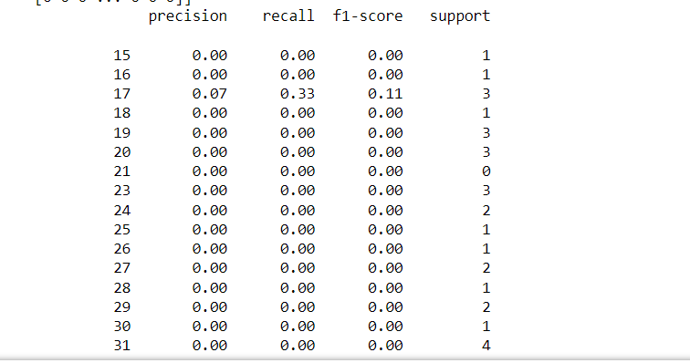
SUMMARY

Conclusions:
- Customer Spending Behaviour:
  - The analysis of total money spent on books reveals distinct spending patterns among customers, highlighting the need for targeted marketing strategies based on spending levels.
- Demographic Influence:
  - Gender analysis indicates significant differences in purchasing behaviour, suggesting that marketing efforts should be tailored to different demographics to enhance engagement and sales.
- Category Preferences:
  - Heatmap visualizations show correlations between various book categories, indicating which categories are most popular among customers. This can inform inventory and promotional strategies.
- Segmentation Opportunities:
  - Customer segmentation based on buying patterns allows for the identification of distinct groups within the customer base. This enables personalized marketing approaches that can improve customer satisfaction and retention.
- Model Performance Metrics:
  - Evaluation metrics such as precision, recall, and F1-score provide insights into the effectiveness of predictive models used for understanding customer behaviour, indicating areas for improvement in model training and data collection.
Insights:
- Targeted Marketing Campaigns:
  - By understanding customer demographics and spending patterns, the book club can design targeted campaigns that resonate with specific segments, potentially increasing conversion rates.
- Product Recommendations:
  - Insights into category preferences can enable personalized product recommendations, enhancing the shopping experience and increasing sales.
- Data-Driven Decision Making:
  - Utilizing EDA and visualizations empowers the book club to make informed decisions based on data, rather than assumptions, leading to more effective business strategies.
- Improved Customer Engagement:
  - Tailoring communication and promotional efforts based on customer segments can enhance engagement and loyalty, fostering a stronger community around the book club.
- Continuous Improvement:
  - Regular evaluation of customer data and model performance can help the book club adapt to changing customer preferences and improve overall operational effectiveness.
These conclusions and insights collectively guide strategic decision-making, aiming to optimize customer satisfaction and drive business growth in the Charles Book Club.

PART – 02 – Tayko.CSV

- Import the dataset and read first few lines of rows
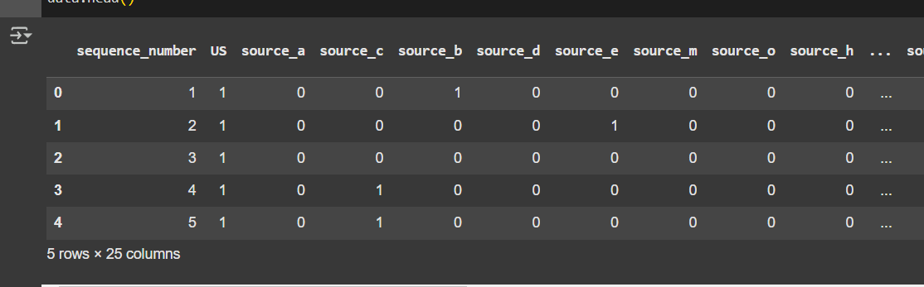

- Data Cleaning and Handling Missing Values
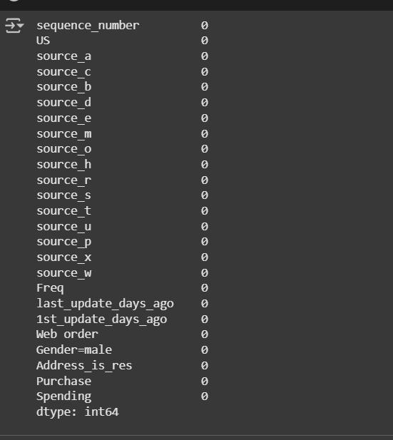

- Displaying the cleaned Values
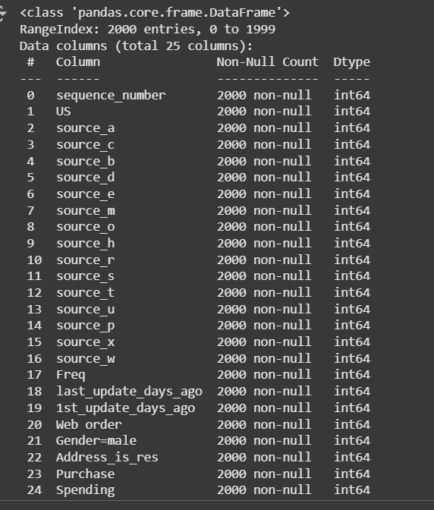

- Finding out missing values per column
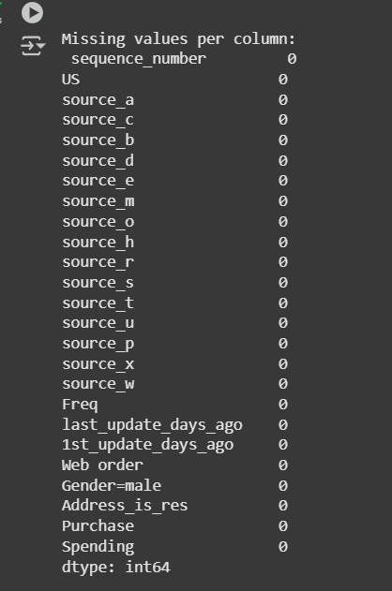

- Exploring numerical features
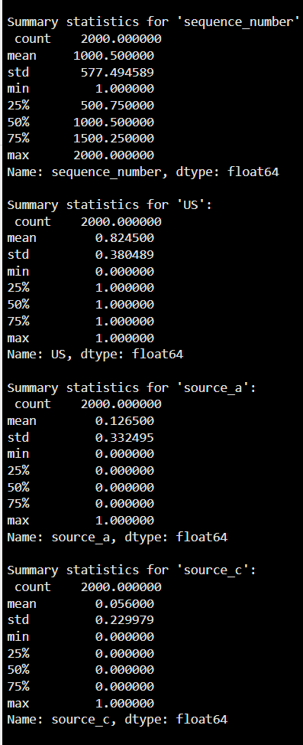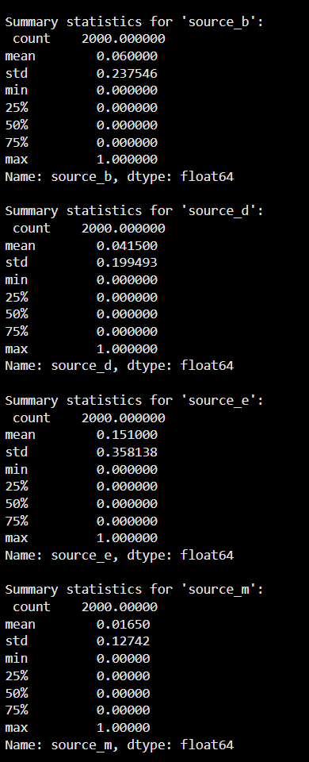

- Histogram targeting spending column
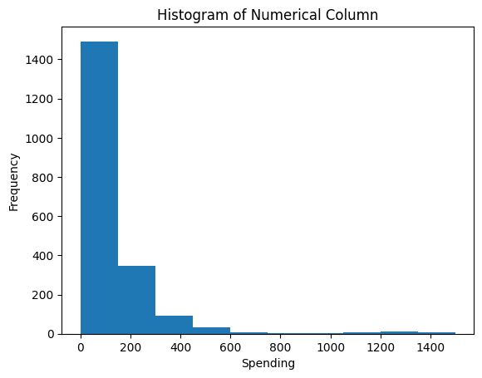

Logistic Regression Model

Using Spending as a target variable
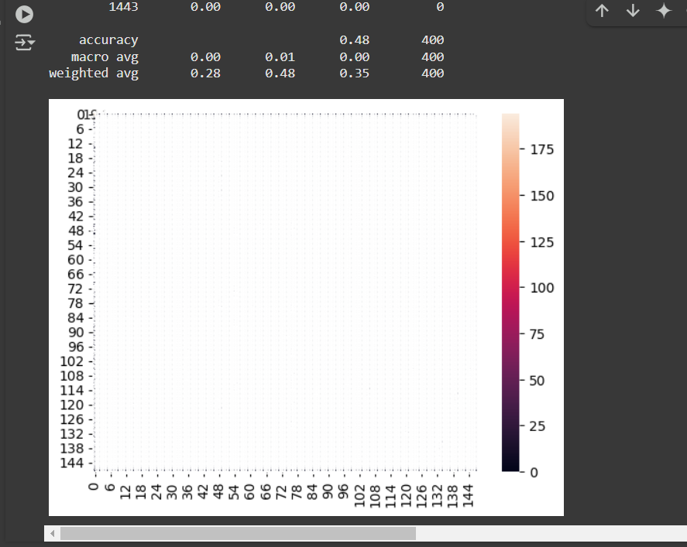

Evaluate model using a confusion matrix, accuracy, precision, recall, and F1-score.

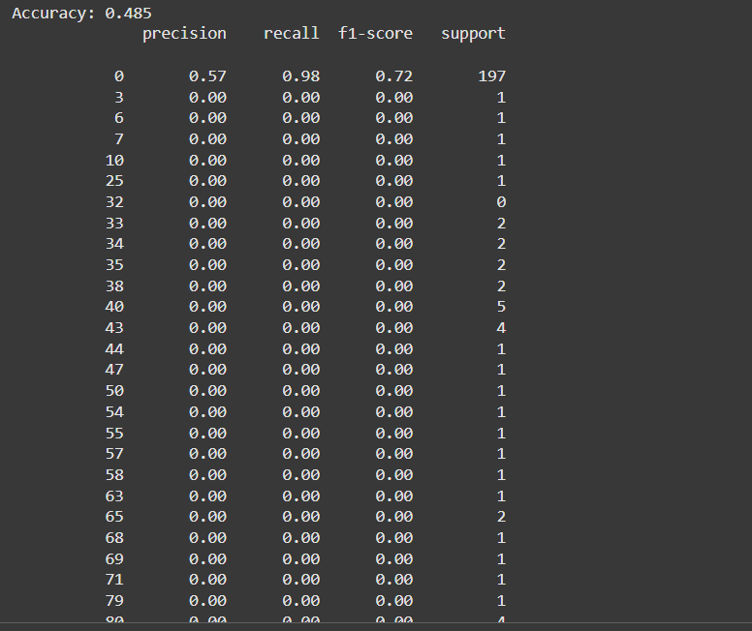

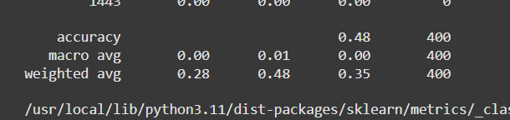

Detailed Summary for Part 2 – Tayko.CSV
- Dataset Import:
  - The dataset, Tayko.CSV, is read into a suitable data structure (e.g., DataFrame in Python using pandas). The first few rows are displayed to provide a snapshot of the data, including column names and initial values. This helps in assessing the overall format and identifying any immediate issues with the dataset.
- Data Cleaning and Handling Missing Values:
  - Missing values are identified using functions such as is null () or isnad(), and the proportion of missing data per column is calculated. Strategies are implemented to handle these missing values, which may include:
    - Removing rows with excessive missing values.
    - Imputing missing values with the mean, median, or mode, depending on the data type and distribution.
  - The cleaned dataset is then confirmed by displaying the updated values, ensuring that missing data has been addressed without compromising the dataset's integrity.
- Displaying Cleaned Values:
  - After cleaning, the cleaned dataset is displayed to illustrate the changes made. This can involve checking for any remaining missing values and ensuring that all columns contain appropriate data types.
- Finding Missing Values per Column:
  - A thorough examination is conducted to quantify the missing values for each column. This step is crucial to understand which features may impact the analysis and to decide on further cleaning or transformation steps.
- Exploring Numerical Features:
  - Key numerical features are explored using descriptive statistics (mean, median, standard deviation) and visualizations (e.g., histograms, boxplots). This exploration helps to uncover patterns and anomalies in the data, such as skewness or outlier presence.
- Histogram Targeting Spending Column:
  - A histogram focusing on the spending column is created. This visualization helps in understanding the distribution of customer spending, revealing whether the data follows a normal distribution, is skewed, or has multiple peaks. Specific insights may include:
    - Identification of spending thresholds (e.g., low, medium, high spenders).
    - Detection of outliers or unusual spending patterns, which may warrant further investigation.
- Logistic Regression Model:
  - A logistic regression model is developed using spending as the target variable. The model is designed to predict binary outcomes (e.g., whether a customer is likely to spend above a certain threshold). The following steps are typically involved:
    - Feature selection: Choosing relevant predictors based on correlation analysis and feature importance.
    - Model fitting: Using training datasets to estimate the model coefficients.
    - Applying regularization techniques (if necessary) to prevent overfitting.
- Model Evaluation:
  - The performance of the logistic regression model is evaluated using several metrics, including:
    - Confusion Matrix: To visualize the true positives, true negatives, false positives, and false negatives, providing insights into the model's predictive capabilities.
    - Accuracy: The overall correctness of the model's predictions.
    - Precision: The proportion of true positive results in relation to all positive predictions, indicating the model's ability to avoid false positives.
    - Recall: The proportion of true positive results in relation to all actual positives, reflecting the model’s ability to identify all relevant cases.
    - F1-Score: The harmonic mean of precision and recall, offering a balance between the two metrics and a single score for model performance.

Specific Insights:
- Customer Segmentation: The analysis reveals distinct spending patterns, allowing for segmentation of customers into different categories (e.g., high spenders, low spenders). This insight can inform targeted marketing strategies.
- Predictive Insights: The logistic regression model's evaluation metrics suggest areas of improvement in predictive accuracy, indicating that additional features or more advanced modelling techniques (e.g., decision trees, ensemble methods) might enhance performance.
- Data-Driven Strategies: By understanding spending behaviours and the factors influencing them, the business can tailor its offerings and marketing campaigns, ultimately driving higher conversion rates and customer satisfaction.
This detailed analysis serves as a foundation for strategic decision-making, enabling the business to adapt and respond to customer needs effectively.

